

## AIR QUALITY DETECTION

# **TEAM MEMBERS:**

V.Sriya Chaitanya - 21911A3560

V.Chandana - 21911A3561

Vishal Giri - 21911A3563

Naga Vardhan – 21911A3564

**Faculty Signature**

**Project Abstract:**

It is a product which works with the help of sensors and helps in detection of amount of Carbon dioxide and Oxygen and triggers the alarm when it exceeds its range.

**Introduction:**

Ensuring the safety and air quality in both personal and industrial environments is crucial due to the potential hazards posed by elevated levels of Carbon Dioxide (CO₂) and Oxygen (O₂). The CO₂ and O₂ detection project aims to address these concerns by developing a sensor-based system capable of real-time monitoring and alerting. This system employs advanced sensors to measure the concentrations of CO₂ and O₂, triggering alarms when these gases exceed safe levels. The primary applications include preventing suffocation incidents in enclosed spaces and detecting gas leaks in industrial settings.

The project leverages the MQ-9 gas sensor module, known for its sensitivity to various gases including CO₂, to ensure accurate detection. By providing immediate alerts through alarms or automated actions like opening windows, the system significantly enhances safety measures. This innovative solution not only protects human lives but also mitigates the risk of industrial accidents, making it a vital tool for maintaining air quality and safety standards.

**Components Required:**

* Jumper wires
* Arduino-UNO
* MQ9 Sensor

**Circuit Diagram and Prototype:**

CIRCUIT DIAGRAM:

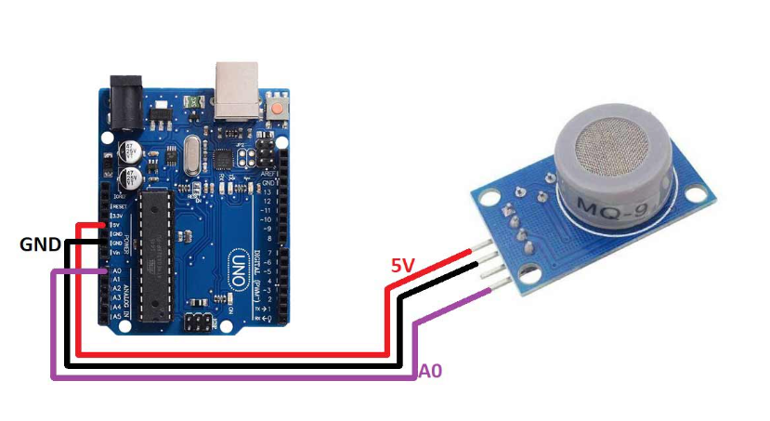

PROTOTYPE:

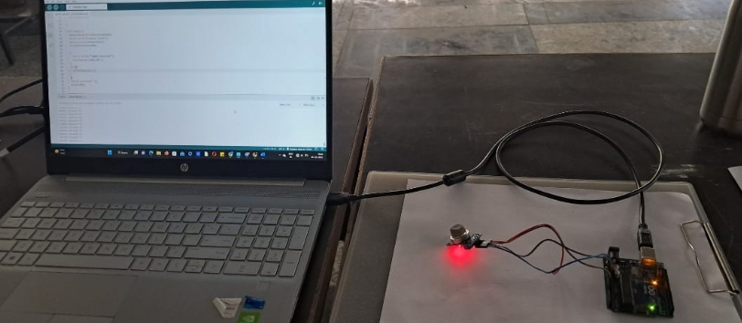

**PROCEDURE:**

**1.Component Assembly**:

* Connect the **MQ-9 gas sensor** to the **microcontroller** (Arduino).
* Attach the **buzzer** for audible alarms.
* Connect the **display module** (LED) to show real-time gas levels.
* Use **connecting wires** for prototyping and connections.
* Connect the VCC pin of the sensor to the 5V pin of the Arduino UNO board
* Connect the GND pin of the sensor to the GND pin of the Arduino UNO board
* Connect the AO pin of the sensor to the A0 pin of the Arduino UNO board

**2.Coding and Configuration:**

* Write a program for the microcontroller to read data from the MQ-9 sensor.
* Set predefined thresholds for CO₂ and O₂ levels.
* Include logic to trigger the buzzer and display data when gas levels exceed thresholds.

**3.Testing and Calibration:**

* Test the system in a controlled environment.
* Calibrate the sensor to ensure accurate readings.
* Adjust thresholds based on testing results.

**4. Deployment:**

* Place the system in the desired monitoring location.
* Power the system using a suitable **power supply** (battery or USB).
* Monitor the gas levels and ensure the alarm functions correctly.

**SOURCE CODE:**

int SmokeA0=A0;

int buzzer =11;

float Sensorvalue;

void setup()

{

pinMode(buzzer,OUTPUT);

pinMode(SmokeA0,INPUT);

Serial.begin(9600);

Serial.println("Gas sensor warning");

delay(2000);

noTone(buzzer);

}

void loop()

{

Sensorvalue=analogRead(SmokeA0);

Serial.print("sensor value");

Serial.print(Sensorvalue);

if (Sensorvalue>200)

{

Serial.print("smoke detected");

tone(buzzer,1000,200 );

}

else{

noTone(buzzer);

Serial.println(" ");

delay(200);

}

}

**Conclusion/Result:**

According to problem when certain type of data identified from the gas then , when data value is greater than the expected value then using the python script for Arduino, we send a single through the transmitter only 1 or 0 if 1 received by receiver then windows will open or buzzer signal will be generated using the MQ-9 sensor.

 MQ-9 gas sensor module has high sensitivity to Carbon Monoxide, Methane and LPG. MQ-9 usually applied in domestic gas leakage detector, industrial gas detector, portable gas detector, etc.

**Scope for future extension:**

* Our technology model helps in the detection of the harmful gases around you, and gives you a signal in order to prevent further accidents.
* This situation is the best way you can protect your infants and pets through the respiratory problems and deaths due to these harmful gases.
* So, this technology enhances the productivity of cars and increase in technology basis for the safety of human beings.
* **Immediate Alerts**: Provides real-time detection and signalling to prevent accidents.
* **Enhanced Safety**: Improves air quality monitoring in various environments.
* **Future Extensions**: Potential for integration with more advanced features and wider applications.